Name: Nadeem osama abdelghany

B.N: 981

**Topic:**

**Programming languages**

**Application brief**

Computer programming language, any of various languages for expressing a set of detailed instructions for a digital computer. Such instructions can be executed directly when they are in the computer manufacturer-specific numerical form known as machine language, after a simple substitution process when expressed in a corresponding assembly language, or after translation from some “higher-level” language. Although there are many computer languages, relatively few are widely used. And there are some of it

The C programming language was developed for programming computer operating systems. Its capacity to structure data and programs through the composition of smaller units is comparable to that of ALGOL. It uses a compact notation and provides the programmer with the ability to operate with the addresses of data as well as with their values.

The C++ language, developed in the mid-1980s, extended C by adding objects to it while preserving the efficiency of C programs. It has been one of the most important languages for both education and industrial programming.

Python is an advanced programming language that is interpreted, object-oriented and built on flexible and robust semantics.

**Screen shoots for web site.**

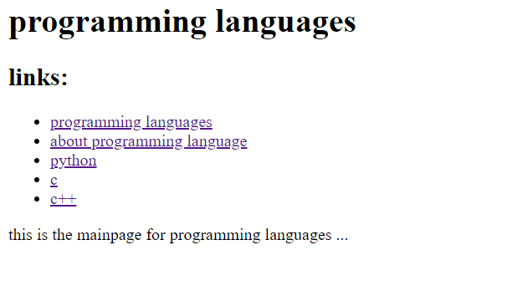

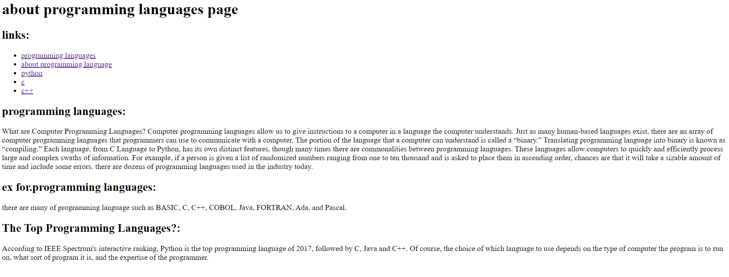

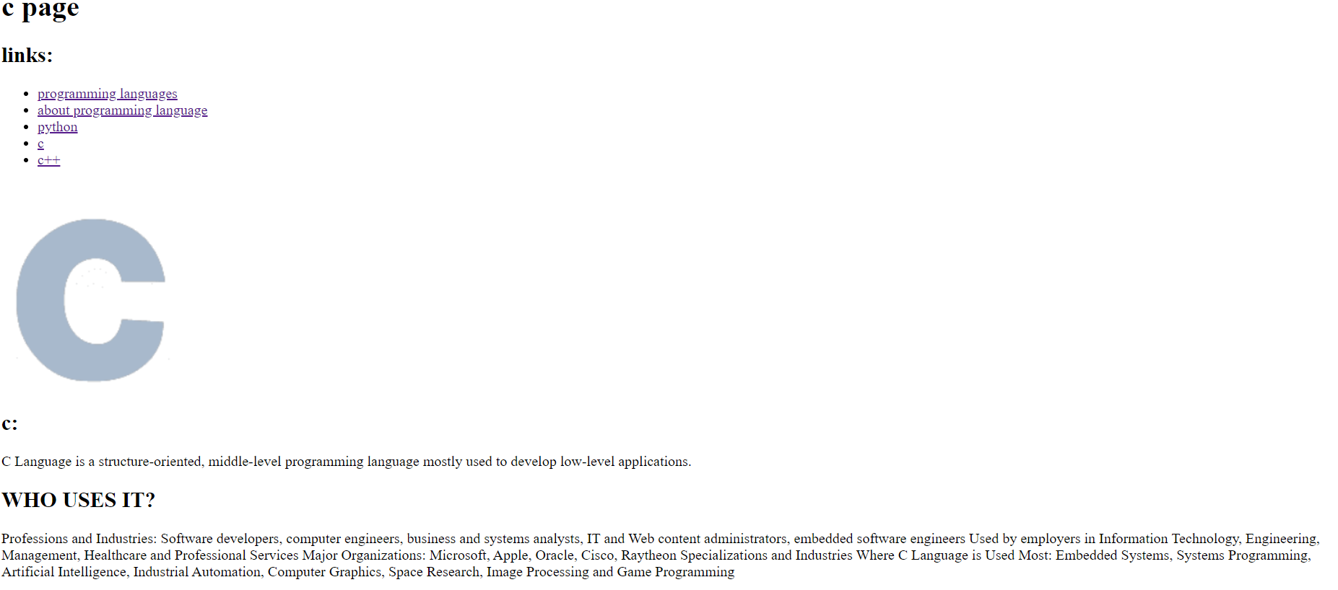

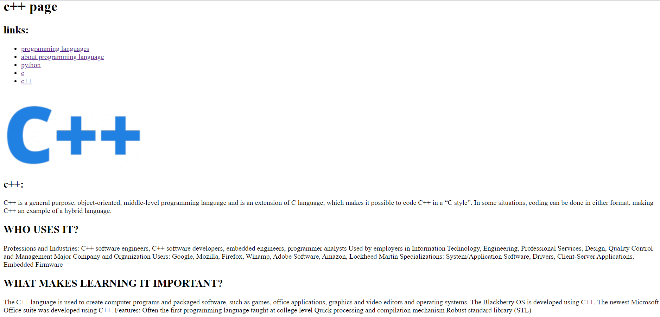

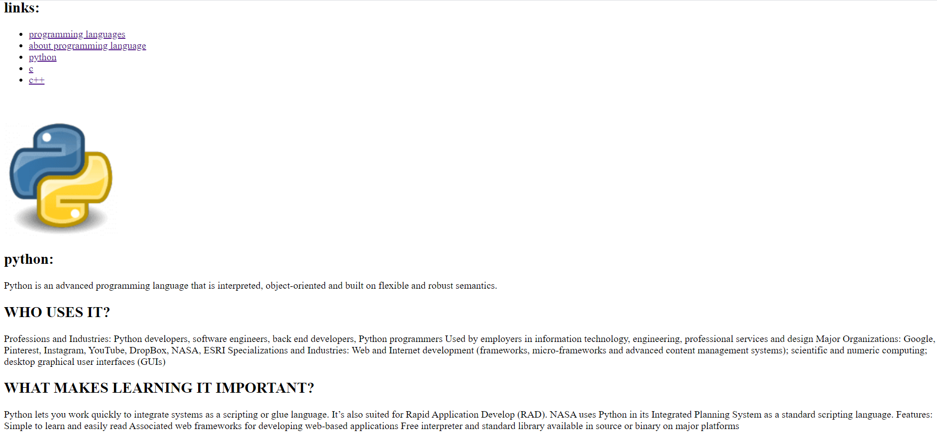

**Source code.**

